Term Project

Caitie Schrotberger
Bellevue University
DSC-500 Introduction to Data Science
Prof. Catherine Williams
July 21, 2023
Term Project
On March 13,2020, the COVID-19 pandemic officially hit the United States as the Trump Administration declared a national emergency (Centers for Disease Control and Prevention, 2023). Having originated overseas, the spread of the virus moved fast and quickly. As this was the first major illness to impact the United States in decades, we were not prepared. All people from Federal, State, and Local governments became consumed with finding the best way to fight disease spread and death. As the pandemic evolved, there were many different strategies that were used to help the US Population.
As the Public Health Emergency (PHE) has officially ended on May 11, 2023, many of the changes to policy that occurred during the heat of the pandemic have ended including changing in data reporting and disease surveillance, test cost to citizens, waivers and other flexibilities for Medicare, Medicaid and Healthcare providers will end (U.S. Department of Health and Human Services, 2023). Other items the Federal administration did was implement the Coronavirus Aid, Relief, and Economic Security (CARES) Act to provide families with funding, expanded unemployment benefits, loans to businesses, funding to state and local governments to support response to the pandemic (Center for Disease Control and Prevention, 2023), (Bartik et all, 2020). Additionally federal student loan payments were paused in March 2020 and have yet to resume (Federal Student Aid, 2023).
Having been actively involved in the pandemic response at the state level and personally, the topic for my course project relates to the country and how it will respond to the PHE ending. My topic is: Is the official end of the COVID-19 PHE and removal of its associated benefits going to hurt US Citizens more than the benefits they provided during the three-year pandemic? The related research areas will be as follows:
- The Medicaid Unwind will remove people from health care that really need it.
- Not having free vaccinations available to all will increase disease spread.
- The business loans to essential businesses were only a band aid in helping them remain open.
- Restarting student loan payments will hurt families financially.
- The student loan discharge will only help a portion of the Citizens in the country.
For content, here is some initial graphics are on the basics of the disease spread, vaccination coverage, and Medicaid coverage changing.
Figure 1
COVID-19 Statistics to Date
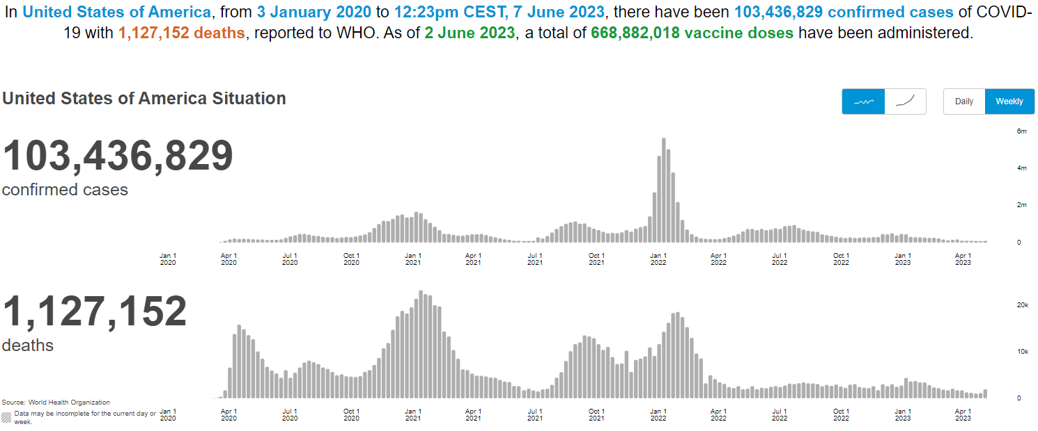
(World Health Organization, 2023)
Figure 2
COVID-19 Vaccination Rates to Date
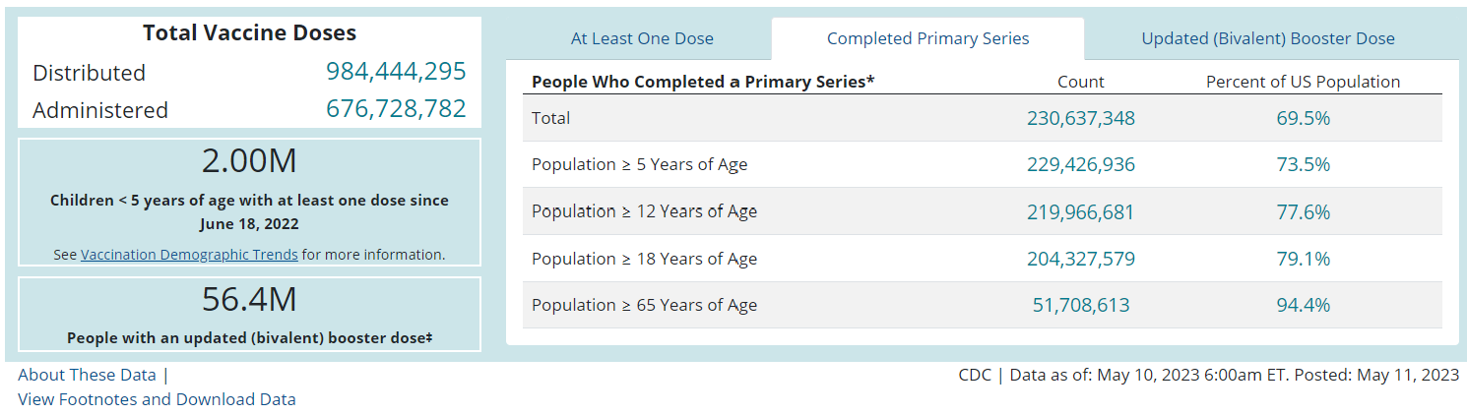
(Centers for Disease Control and Prevention, 2023)

Figure 3
Google trends search on “millions lose Medicaid coverage”.
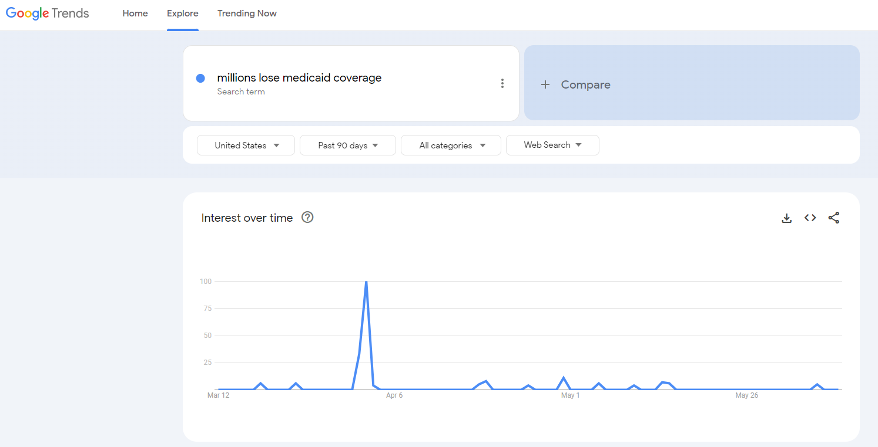
(Google Trends, 2023)

Federal Legislation
The U.S. House and Senate passed several bills which were signed into law during March 2022. The first was the Coronavirus Preparedness and Response Supplemental Appropriations Act which provided funding for research and development of vaccines, therapeutics and diagnostics related to COVID, Small Business Administration (SBA) disaster loans, expanded telehealth services (KFF, 2020, March 11). The second was the Families First Coronavirus Response Act (FFCRA)which provided increased funding for nutritional assistance programs such as Special Supplemental Nutrition Program for Women, Infants, and Children (WIC) and Supplemental Nutrition Assistance Program (SNAP), Emergency Paid Sick Leave, and expanded provisions to cover the cost of COVID testing (KFF, 2020, March 18). The third was the Coronavirus Aid, Relief, and Economic Security (CARES) Act which provided additional funding of COVID testing, prevention and treatment, increased funding for families under the Temporary Assistance for Needy Families (TANF) program, many changes to Medicare & Medicaid, funding for hospitals for COVID related care (KFF, 2020, April 9). The final was the Response & Relief Act which included additional add for small businesses, extended unemployment benefits, stimulus check, educational funding, CARES Act extensions, and many other benefits (CRFB, 2020). In total the passed laws provided $4 trillion in COVID relief at a cost of over $3.4 trillion (CRFB, 2021).
Medicaid Unwind
With the enactment of the FFCRA, federal funding was provided to increase Medicaid funding to states. The biggest part of this funding was the requirement of continuous coverage which prohibited states from terminating most Medicaid enrollees’ coverage until after the end of the PHE (CBPP, 2023). The unwinding of continuous coverage means that all Medicaid covered recipients must requalify through the renewal process for continued coverage. The benefit during the pandemic was that there wasn’t a high rate of uninsured people. The unwind started April 1, 2023. If enrollees don’t complete a renewal or no longer qualify, they will no longer have coverage. The impact of the unwind at the state level includes many major decisions such has how they will communicate with recipients, how to update contact information, how long to process reviews, how to update CMS on progress, and how to effectively staff for the increased volume. (CBPP, 2023)
Analysts currently predict that between 7 and 24 million people could lose Medicaid coverage indicating an 8%-28% decline in enrollment. Because renewals were not required, which prior to the pandemic had occurred yearly, there are many enrollees who started Medicaid coverage during the pandemic that do not know that they must go through the renewal process to continue coverage. Additionally, they anticipate that certain populations of people such as those with limited English proficiency, disabilities, and older adults will be at risk of losing Medicaid coverage. (KFF, 2023).

Free Vaccinations
COVID-19 Vaccinations are 95% effective in preventing COVID-19 transmission, especially in older adults (Moghadas, 2020). If vaccinations were not available freely, that would increase spread especially to vulnerable populations who have limited or no access to health care. Federal funding efforts provided vaccines, testing, treatments, and research to identify emerging variants (The White House, 2022).
Small Business Assistance
The pandemic hit the country fast and hard. Reactions were varied but firm. The “lock down” at varying levels impacted all business and workers. Not being able to go eat in a restaurant or only able to leave the house once a week to purchase essentials hurt the economy, especially small businesses who were not financially prepared to endure a long-term impact on their income. As a result, mass layoffs occurred, and businesses were at risk of remaining open due to the anticipated pandemic length. Very few small businesses had cash on hand in case of emergency, of those that did that funding would only support them for about 2 weeks. PNAS did a survey of almost 6,000 small businesses at the end of March 2020. At that time 43% of the businesses had temporarily closed due to COVID citing reductions in demand and health concerns of the employees. The industries hit hardest were retail, entertainment, food services and the hospitality industry. Those with more cash on hand had a higher likelihood of being open by the end of 2020 as evidenced in Figure 4 (PNAS, 2021).
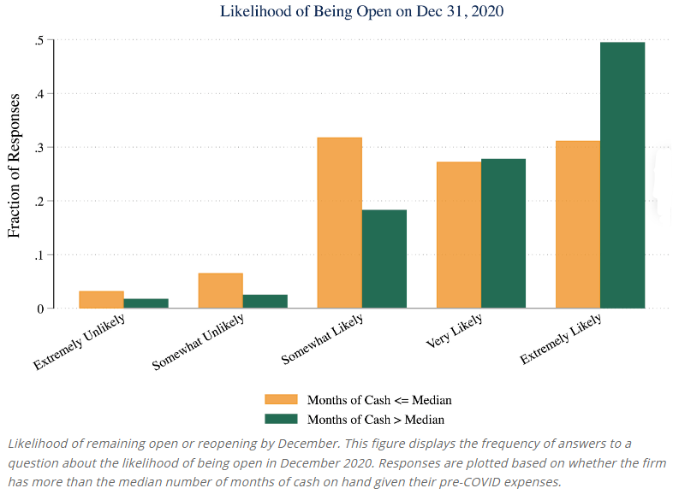
Figure 4

PNAS (2021)
The survey looked at many more metrics and asked about the business’s future. The conclusion of the survey research indicated that many were likely to close without financial assistance. There were apprehensions about taking out Paycheck Protection Program (PPP) Loans because of the hassle in the process to get qualified for a loan, but several businesses were going to take advantage of it. (PNAS, 2021).
Student Loan Deferral
On March 13, 2020, President Trump announced the elimination of interest on federal student loans on the 42 million Americans with more than a total of $1.5 trillion outstanding in loans (Stratford, 2020). The following week, the US. Department of Education announced the suspension of payments for two months, which has now turned into more than three years (Custer, 2022). The goal was to take the financial burden of loan payments off borrowers during the pandemic. While this action was welcomed by the borrowers it has also caused confusion as to the next steps and the timing of when payments will resume.

Student Loan Discharge
Along with the payment deferral and no interest being charged, the President has investigated discharging varying student loan debt. They adjusted the Public Service Loan Forgiveness (PSLF) waver to allow more people to qualify for that program. The income-driven repayment method was adjusted to make payments, when resumed, more affordable. Students who attended institutions where they misled, defrauded or lied were granted automatic discharge of their loans (Custer, 2022). Additionally, the President is pushing for discharge of a fixed amount of loan for each borrow which was recently stopped by the Supreme Court.
The payment pause has cost about $5 billion per month. It also benefits borrowers who earned higher degrees because they tend to have higher loan balances, and thus those with high incomes (see Figure 5). The pandemic caused many unforeseen changes in citizen’s life plans. They may have lost a job, had a change in family circumstances, or other kind of financial shock which would make resuming payment on student loans even more difficult. (Turner, 2023)
Figure 5
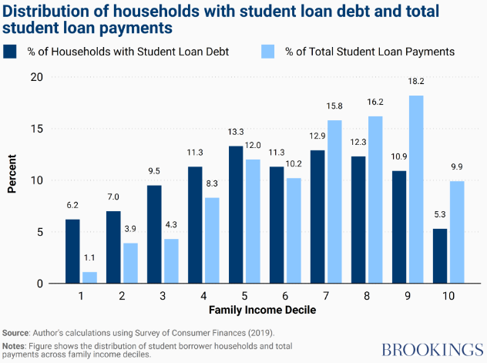
Turner (2023)
Assumptions
All of the COVID-19 programs and actions were done without prior evaluation or testing. Based on this, they were guessing on how to react to and support the public during the pandemic. The assumption is that all implemented programs were evaluated to be successful or necessary before being offered to the public. Additionally, the assumption is that the government and press presented accurate factual data to support their opinion.
Ethical Concerns
There are so many ethical concerns with a global pandemic. As it relates to COVID-19, because of the many faucets of the pandemic from quarantine, to testing, to vaccination, to reporting, and analytics there were ethical concerns in all of it. The biggest word used during the pandemic was the vulnerable or vulnerability of specific populations (Maeckelberghe, 2021) and how it was defined in multiple different ways depending on who was providing the information or how it was being used to treat or server people during the pandemic. This would cause people to be included or excluded from programs based on how being vulnerable was defined. There were multiple known reporting issues at multiple levels that made the public question the reliability of the data and actions taken as a result of the data.
Challenges and Opportunities
The world has learned a lot since this global pandemic. Since we are still close to the beginning of the outbreak it will take more time to fully evaluate the effectiveness and efficiencies of the programs that were changed to help the public during the pandemic. Every country reacted differently and we can learn from their successes and failures. There is still a lot of analytics that can be done on the pandemic to ensure programs were successful in obtaining their objectives.

Conclusion
There have been several different levers that the federal government has pulled during the pandemic. Some of them have been straightforward and beneficial while the others are drawn out and confusing. Providing free vaccination and treatment of COVID-19 and loans to small business to keep them operating did benefit many citizens. The others which have not fully resolved appear to be set up to hinder citizens’ health or financial standing. Removing people from Medicaid will provide them with no health care and limited information on how to get insurance resulting in poor health outcomes. Resuming student loan payments will increase the financial burden on borrowers in an already inflated economy.
Based on the above research, only federal policy implemented at directly combatting the spread of the virus was the most effective. Providing small business financial assistance and helping with healthcare for needy populations was a targeted approach that only helped a portion of the population. The student loan payment pause, 0% interest, and possible means of discharge have been confusing to those with outstanding student loans and will probably cause financial hardship when payments resume.

References
Bartik, A., Bertrand, M., Cullen, Z., Glaeser, E., Luca, M., and Stanton, C. (2020). The impact of COVID-19 on small business outcomes and expectations. National Library of Medicine, DOI 10.1073/pnas.2006991117. https://www.ncbi.nlm.nih.gov/pmc/articles/PMC7395529/
CBPP. (2023, April 28). Unwinding the Medicaid Continuous Coverage Requirement. https://www.cbpp.org/research/health/unwinding-the-medicaid-continuous-coverage-requirement
Centers for Disease Control and Prevention. (2023, March 15). CDC Museum COVID-19 Timeline. https://www.cdc.gov/museum/timeline/covid19.html
Centers for Disease Control and Prevention. (2023, May 11). COVID Data Tracker. https://covid.cdc.gov/covid-data-tracker/#vaccinations_vacc-total-admin-rate-total
CRFB. (2020, December 21). What's in the Final COVID Relief Deal of 2020? https://www.crfb.org/blogs/whats-final-covid-relief-deal-2020
CRFB. (2021, January 7). Breaking Down $3.4 Trillion in COVID Relief. https://www.crfb.org/blogs/breaking-down-34-trillion-covid-relief#:~:text=Of%20the%20%243.4%20trillion%20in,from%20the%20other%20two%20bills.
Custer, B. (2022, August 9). Timeline: Federal Student Loans During the COVID-19 Pandemic. https://www.americanprogress.org/article/timeline-federal-student-loans-during-the-covid-19-pandemic/
Federal Student Aid. (2023). COVID-19 Loan Payment Paus and 0% Interest. https://studentaid.gov/announcements-events/covid-19/payment-pause-zero-interest
Google Trends. (2023, June 11). Millions lose Medicaid coverage. https://trends.google.com/trends/explore?date=today%203-m&geo=US&q=millions%20lose%20medicaid%20coverage
KFF. (2020, March 11). The U.S. Response to Coronavirus: Summary of the Coronavirus Preparedness and Response Supplemental Appropriations Act, 2020. https://www.kff.org/global-health-policy/issue-brief/the-u-s-response-to-coronavirus-summary-of-the-coronavirus-preparedness-and-response-supplemental-appropriations-act-2020/
KFF. (2020, March 18). The Families First Coronavirus Response Act: Summary of Key Provisions. https://www.kff.org/global-health-policy/issue-brief/the-families-first-coronavirus-response-act-summary-of-key-provisions/
KFF. (2020, April 9). The Coronavirus Aid, Relief, and Economic Security Act: Summary of Key Health Provisions. https://www.kff.org/coronavirus-covid-19/issue-brief/the-coronavirus-aid-relief-and-economic-security-act-summary-of-key-health-provisions/
KFF. (2023, June 29). 10 Things to Know About the Unwinding of the Medicaid Continuous Enrollment Provision. https://www.kff.org/medicaid/issue-brief/10-things-to-know-about-the-unwinding-of-the-medicaid-continuous-enrollment-provision/
Maeckelberghe, E. (2021, November 09). Ethical implications of COVID-19: vulnerabilities in a global perspective. https://academic.oup.com/eurpub/article/31/Supplement_4/iv50/6423457
Moghadas, S. M., Vilches, T. N., Zhang, K., Wells, C. R., Shoukat, A., Singer, B. H., Meyers, L. A., Neuzil, K. M., Langley, J. M., Fitzpatrick, M. C., & Galvani, A. P. (2021). The impact of vaccination on COVID-19 outbreaks in the United States. medRxiv : the preprint server for health sciences, 2020.11.27.20240051. https://doi.org/10.1101/2020.11.27.20240051. https://www.ncbi.nlm.nih.gov/pmc/articles/PMC7709178/
PNAS (Proceedings of the National Academy of Sciences). (2020, July 10). The impact of COVID-19 on small business outcomes and expectations. https://www.pnas.org/doi/10.1073/pnas.2006991117
Stratford, M. (2020, March 13). Trump to waive interest on federal student loans ‘until further notice’. https://www.politico.com/news/2020/03/13/trump-administration-student-loan-payments-suspension-128181
Turner, S. (2023, April 13). Student loan pause has benefitted affluent borrowers the most, others may struggle when payments resume. https://www.brookings.edu/articles/student-loan-pause-has-benefitted-affluent-borrowers-the-most-others-may-struggle-when-payments-resume/
U.S. Department of Health and Human services. (2023, May 9). Fact Sheet: End of the COVID-19 Public Health Emergency. https://www.hhs.gov/about/news/2023/05/09/fact-sheet-end-of-the-covid-19-public-health-emergency.html
The White House. (2022, March 12). FACT SHEET: Consequences of Lack of Funding for Efforts to Combat COVID-⁠19 if Congress Does Not Act https://www.whitehouse.gov/briefing-room/statements-releases/2022/03/15/fact-sheet-consequences-of-lack-of-funding-for-efforts-to-combat-covid-19-if-congress-does-not-act/
World Health Organization. (2023). Coronavirus disease (COVID-19). https://www.who.int/health-topics/coronavirus#tab=tab_1

Potential to use still:
JPMorganChase. (2020, July). Small Business Financial Outcomes during the COVID-19 Pandemic. https://www.jpmorganchase.com/institute/research/small-business/report-small-business-financial-outcomes-during-the-covid-19-pandemic
FEMA. (2023, June 14). COVID-19 Funeral Assistance. https://www.fema.gov/disaster/historic/coronavirus/economic/funeral-assistance

